[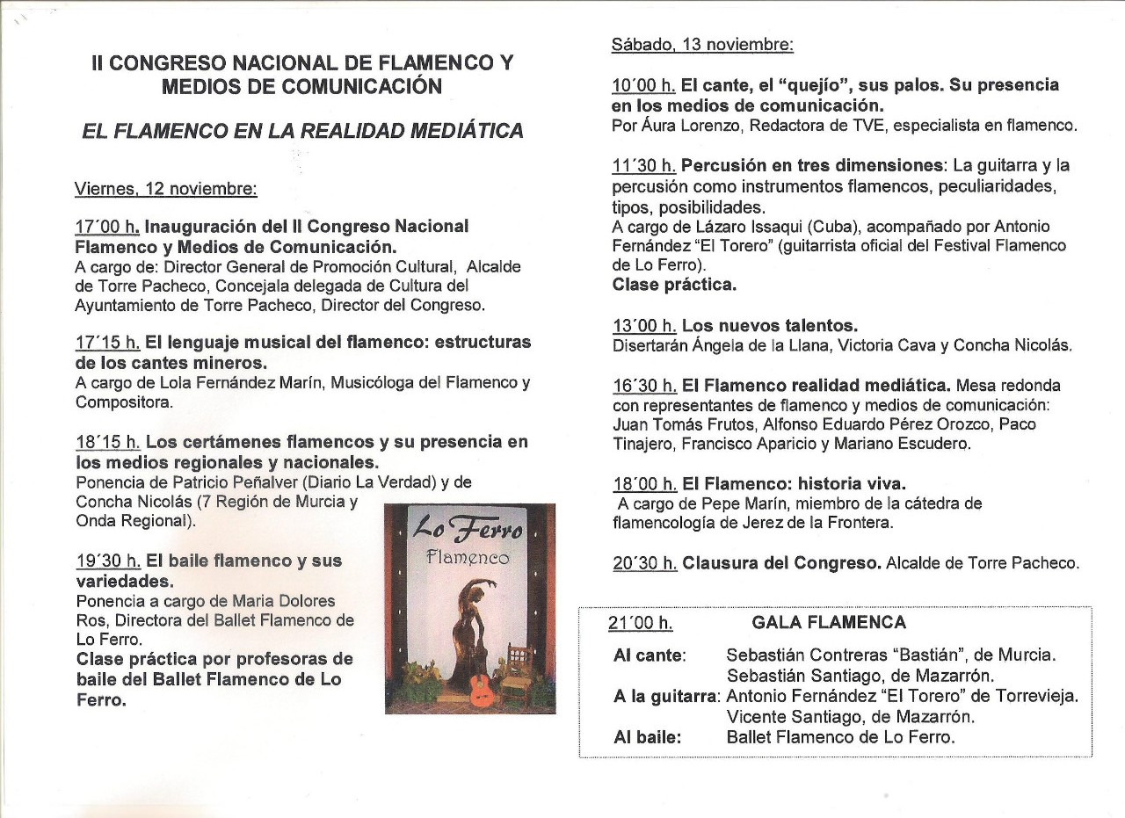](http://files.loferroflamenco.com/200000864-8b78d8c72a/PROGRAMA%20II%20CONGRESO%20001.jpg)